Internship Project 2-HTML To-Do List

ABSTRACT
In today’s fast-paced digital world, task management plays a crucial role in ensuring productivity, organization, and efficient use of time. The HTML To-Do List project is designed to provide a simple, interactive platform where users can manage their daily tasks efficiently. Unlike traditional pen-and-paper lists, a digital To-Do List offers the advantage of accessibility, interactivity, and automation. This project focuses on the development of a web-based To-Do List application using core front-end technologies such as HTML for structure, CSS for styling, and JavaScript for dynamic functionality.
The main functionality of the application revolves around creating, updating, and deleting tasks. Users can enter tasks into an input field, which then appear dynamically in a list format. Each task can be marked as complete or removed entirely, offering flexibility in task management. By using client-side technologies, the project eliminates the need for backend databases, making it lightweight and easy to deploy on any local or online web server.
This project not only demonstrates technical skills in front-end web development but also highlights practical applications in daily life. Interns gain experience in DOM manipulation, event handling, and creating responsive user interfaces. Additionally, the project serves as an introductory example of how interactive web applications are developed, forming a foundation for more advanced projects involving backend integration, databases, or cloud storage.
The HTML To-Do List represents an important step in understanding user-centric design, where simplicity, accessibility, and functionality are prioritized. By integrating design and logic, the project provides a real-world solution for task organization, thereby improving personal productivity and helping individuals develop better work habits. Furthermore, it emphasizes the importance of web technologies in modern applications and encourages learners to explore additional features such as task prioritization, categorization, and notifications in future extensions.
OBJECTIVE

The primary objective of this project is to develop a functional and user-friendly To-Do List application that demonstrates the practical application of core front-end web technologies, including HTML, CSS, and JavaScript. While the project is simple in its concept, it serves as an effective platform for interns and beginners to understand the fundamental principles of web development while simultaneously applying these concepts to a real-world productivity tool. The project emphasizes the importance of creating interactive, visually appealing, and functional web applications that can be used in everyday life.

Key Objectives of the Project
Task Creation and Management
- The primary goal of the To-Do List is to provide users with a structured platform to add, view, and manage tasks effectively.
- Users can enter tasks into the application, which are immediately displayed in a dynamic list.
- This functionality ensures that tasks are organized in a logical order, allowing users to keep track of their daily activities, deadlines, and priorities.
- By providing an easy mechanism to remove completed tasks, the application ensures that users’ task lists remain clutter-free and up-to-date, reinforcing efficient task management.
Interactive User Experience
- One of the central objectives is to make the To-Do List interactive and responsive to user actions.
- The project incorporates features such as adding tasks either by clicking a button or pressing the Enter key, allowing for seamless task entry.
- Visual feedback, such as marking tasks as completed or highlighting tasks on hover, improves user engagement and usability.
- By integrating these interactive elements, the project not only enhances the user experience but also demonstrates the importance of responsiveness in modern web applications.
Hands-On Front-End Development Practice
- This project serves as a practical exercise in front-end development, providing hands-on experience with HTML for structuring content, CSS for styling and layout, and JavaScript for dynamic functionality.
- Interns learn to implement real-time DOM updates, handle user events, and manipulate HTML elements programmatically.
- These skills form a foundation for more advanced web development projects, including those that involve frameworks like React, Angular, or Vue.js.
Single-Page Application Functionality
- A critical objective is to demonstrate the concept of single-page applications (SPA).
- All tasks, additions, and deletions occur without requiring page reloads, making the application faster, smoother, and more responsive.
- This illustrates how modern web applications focus on enhancing user experience through efficient interaction design and minimizing disruptions during task management.
Understanding DOM Manipulation and Event Handling
- Another major objective is to introduce learners to the Document Object Model (DOM) and how it can be manipulated dynamically using JavaScript.
- Interns gain insight into adding elements, removing elements, updating content, and binding events such as clicks and keypresses.
- Understanding DOM manipulation is essential for developing interactive web applications, making this objective crucial for building a strong technical foundation.
Encouraging Productivity and Organization
- Beyond technical learning, the project aims to create a tool that enhances personal productivity.
- By organizing tasks digitally, users can prioritize their daily activities, track pending work, and ensure deadlines are met efficiently.
- The To-Do List application demonstrates how technology can simplify everyday workflows, highlighting the practical utility of web development skills.
Foundation for Future Development and Scalability
- The To-Do List project is designed to be scalable and extendable.
- Interns can later implement advanced features such as persistent storage using local storage or databases, categorizing tasks, setting reminders and deadlines, and integrating cloud synchronization across devices.
- These enhancements provide opportunities to bridge basic web development skills with full-stack development concepts, making the project a starting point for more complex applications.
INTRODUCTION
In today’s fast-paced digital environment, effective task management has become increasingly important for both students and professionals. Keeping track of daily responsibilities, academic assignments, or workplace tasks can be challenging, especially when multiple priorities overlap. Traditional methods such as pen-and-paper lists or static spreadsheets are often inefficient and lack interactivity. To address these challenges, digital task management tools such as To-Do Lists have emerged as an essential component of personal and professional productivity.
The HTML To-Do List project focuses on creating a simple, interactive, and user-friendly web application that allows users to manage their daily tasks efficiently. By leveraging basic front-end web technologies — HTML for structure, CSS for styling, and JavaScript for dynamic behavior — the project demonstrates how even simple coding concepts can be applied to solve real-world problems. The application runs entirely on the client side, making it lightweight, accessible, and easy to deploy without the need for backend databases.
Importance of a To-Do List
A To-Do List serves as a digital organizer that helps individuals plan, prioritize, and monitor tasks in real time. Unlike static lists, a web-based To-Do List is interactive and dynamic, allowing users to add, delete, and mark tasks as completed instantaneously. This kind of digital organization:
- Reduces the likelihood of forgetting tasks.
- Helps users allocate time efficiently.
- Improves productivity and workflow management.
- Provides a visually appealing interface that enhances user engagement.
The project demonstrates the practical application of front-end programming skills while simultaneously creating a tool that promotes discipline, time management, and task prioritization.
Technologies Used
The To-Do List application utilizes HTML, CSS, and JavaScript, which are fundamental technologies for front-end web development:
- HTML (HyperText Markup Language) – Provides the structure of the web page, including input fields for tasks, buttons for user actions, and the task list displayed as an unordered list (<ul>).
- CSS (Cascading Style Sheets) – Styles the web page, ensuring a clean layout, readable fonts, appropriate spacing, and visual feedback when tasks are marked complete or hovered over.
- JavaScript – Handles the dynamic behavior of the application, including adding, removing, and updating tasks. It also manages event handling (e.g., button clicks, key presses) to create a responsive and interactive user experience.
By combining these technologies, the project highlights the power of front-end web development in creating functional and user-friendly applications.
Features of the HTML To-Do List
The project includes several key features designed to improve user experience and efficiency:
- Task Addition – Users can input tasks and instantly see them appear in the task list.
- Task Deletion – Completed or unnecessary tasks can be removed from the list with a single click, keeping the interface clean.
- Mark as Complete (Optional) – Tasks can be visually marked as complete, often with a strikethrough effect, providing visual feedback on progress.
- Single-Page Operation – All tasks and interactions occur without page reloads, ensuring smooth operation and faster response times.
- Responsive Design – The interface is accessible on desktops, tablets, and mobile devices, demonstrating adaptive design principles.
These features not only make the application functional but also provide interns with hands-on experience in creating dynamic and interactive web pages.
Practical Relevance
The To-Do List project emphasizes the importance of applying programming knowledge to real-world problems. Beyond being an academic exercise, it serves as a useful personal productivity tool. Users can employ the application to organize their daily schedules, plan projects, or track homework assignments. Additionally, by implementing the To-Do List, interns gain insight into best practices in web design, including:
- User-friendly interface design – Ensuring clarity, simplicity, and ease of navigation.
- Dynamic interaction – Updating the user interface in real time without page reloads.
- Logical content structure – Organizing HTML elements in a coherent and reusable manner.
- Scalability for future enhancements – Preparing the application for advanced features such as local storage, task categories, reminders, or cloud integration.
Through this project, interns learn to combine technical proficiency with problem-solving skills, creating a practical application that bridges academic knowledge and real-world utility.
METHODOLOGY
The methodology for developing the HTML To-Do List project follows a structured approach to ensure the application is functional, interactive, user-friendly, and responsive. The project uses HTML, CSS, and JavaScript, focusing on front-end development principles, DOM manipulation, and event handling. The methodology consists of several phases: requirement analysis, planning, designing, implementation, testing, debugging, and optimization.
1. Requirement Analysis and Planning
The first step involved identifying the purpose and scope of the project. The primary goal was to create a simple web application that allows users to add, view, delete, and manage tasks efficiently. During this phase:
Key functionalities were defined:
- Add tasks dynamically.
- Delete tasks from the list.
- Mark tasks as complete with visual feedback.
- Optional: Save tasks locally using localStorage.
- The target audience was identified as students, professionals, or anyone who needs a simple task manager.
- A single-page layout was planned to ensure fast interaction and smooth navigation without page reloads.
2. Designing the User Interface (UI)
Before coding, the layout and interface were carefully designed:
Wireframing:
- A rough sketch was made to arrange the input field, Add button, and task list logically.
- Placement of buttons, spacing, and alignment were planned for clarity and simplicity.
Styling Considerations:
- Used light background colors for better readability.
- Applied contrast colors for buttons and completed tasks.
- Ensured the layout is responsive for desktops, tablets, and mobile devices.

Visual Feedback:
- Hover effects for buttons to indicate interactivity.
- Completed tasks are shown with strikethrough text to indicate completion.
3. Front-End Implementation
Step 1: HTML Structure
Used semantic HTML5 elements to create a clean and organized structure:
- Header (<h1>) for the title.
- Input field (<input>) for task entry.
- Add button (<button>) to submit tasks.
- Unordered list (<ul>) to display tasks dynamically.
Step 2: CSS Styling
- Applied Cascading Style Sheets to enhance the visual appeal.
- Rounded corners, spacing, colors, and hover effects were added to improve user experience.
- A .completed CSS class was implemented to visually differentiate tasks that were completed.

Step 3: JavaScript Functionality
Task Addition:
- Captured the input value and created a new <li> element.
- Added a delete button next to each task.
- Appended the task to the task list dynamically.
Task Deletion:
- Each task has a delete button that removes the task when clicked.
Mark Task Complete:
- Clicking on a task toggles the .completed class to indicate completion.
Step 4: Event Handling
- Enabled task addition via button click or Enter key press.
- Bound click events to delete buttons and task items to enable dynamic interactions.
4. Optional Enhancements
To improve the functionality and usability of the project:
Local Storage Integration:
- Saves tasks to browser storage so they persist even after refreshing the page.
- Retrieves tasks on page load to ensure continuity.
Task Counters:
- Displays total tasks, completed tasks, and pending tasks.
Filtering Options:
- Allows users to view all tasks, active tasks, or completed tasks.

Input Validation:
- Prevents empty tasks from being added.
5. Testing, Debugging, and Optimization
Testing:
- Verified that all functionalities (add, delete, mark complete) work correctly.
- Checked the responsiveness of the layout across desktop, tablet, and mobile devices.
- Tested browser compatibility for Chrome, Firefox, and Edge.
Debugging:
- Resolved JavaScript errors like misfired events or null values.
- Fixed CSS alignment and spacing issues.
Optimization:
- Reduced unnecessary DOM manipulations for performance.
- Ensured code readability and maintainability for future upgrades.

CODE
<!DOCTYPE html>
<html lang="en">
<head>
<meta charset="UTF-8">
<meta name="viewport" content="width=device-width, initial-scale=1.0">
<title>Task Manager</title>
<!-- Bootstrap 5 -->
<link href="https://cdn.jsdelivr.net/npm/bootstrap@5.3.0/dist/css/bootstrap.min.css" rel="stylesheet">
<style>
body {
background: #f8f9fa;
padding: 30px;
}
.container {
background: #fff;
padding: 20px;
border-radius: 12px;
box-shadow: 0 4px 12px rgba(0,0,0,0.1);
}
table {
margin-top: 20px;
}
.action-btn {
cursor: pointer;
margin: 0 5px;
}
</style>
</head>
<body>
<div class="container">
<h2 class="mb-4">📋 Task Manager</h2>
<button class="btn btn-primary mb-3" data-bs-toggle="modal" data-bs-target="#taskModal">Add Task</button>

<table class="table table-bordered table-striped">
<thead class="table-dark">
<tr>
<th>#</th>
<th>Task/Description</th>
<th>Responsible</th>
<th>ETA</th>
<th>Action</th>
</tr>
</thead>
<tbody id="taskTable"></tbody>
</table>
</div>

<!-- Modal for Adding/Editing Task -->
<div class="modal fade" id="taskModal" tabindex="-1" aria-hidden="true">
<div class="modal-dialog">
<div class="modal-content">
<form id="taskForm">
<div class="modal-header">
<h5 class="modal-title">Add/Edit Task</h5>
<button type="button" class="btn-close" data-bs-dismiss="modal"></button>
</div>
<div class="modal-body">
<input type="hidden" id="taskId">
<div class="mb-3">
<label class="form-label">Task/Description</label>
<input type="text" class="form-control" id="taskName" required>
</div>
<div class="mb-3">
<label class="form-label">Responsible</label>
<input type="text" class="form-control" id="taskResponsible" required>
</div>
<div class="mb-3">
<label class="form-label">ETA</label>
<input type="datetime-local" class="form-control" id="taskETA" required>
</div>
</div>
<div class="modal-footer">
<button type="button" class="btn btn-secondary" data-bs-dismiss="modal">Cancel</button>
<button type="submit" class="btn btn-success">Save Task</button>
</div>
</form>
</div>
</div>
</div>

<!-- Bootstrap JS + Popper -->
<script src="https://cdn.jsdelivr.net/npm/bootstrap@5.3.0/dist/js/bootstrap.bundle.min.js"></script>

<script>
let tasks = [];
let editingIndex = null;

const taskTable = document.getElementById("taskTable");
const taskForm = document.getElementById("taskForm");
const taskModal = new bootstrap.Modal(document.getElementById("taskModal"));

function renderTasks() {
taskTable.innerHTML = "";
tasks.forEach((task, index) => {
taskTable.innerHTML += `
<tr>
<td>${index + 1}</td>
<td>${task.name}</td>
<td>${task.responsible}</td>
<td>${new Date(task.eta).toUTCString()}</td>
<td>
<span class="action-btn text-primary" onclick="editTask(${index})">✏</span>
<span class="action-btn text-danger" onclick="deleteTask(${index})">🗑</span>
</td>
</tr>
`;
});
}

taskForm.addEventListener("submit", function(e) {
e.preventDefault();
const name = document.getElementById("taskName").value;
const responsible = document.getElementById("taskResponsible").value;
const eta = document.getElementById("taskETA").value;

if (editingIndex !== null) {
tasks[editingIndex] = { name, responsible, eta };
editingIndex = null;
} else {
tasks.push({ name, responsible, eta });
}

taskForm.reset();
taskModal.hide();
renderTasks();
});

function editTask(index) {
const task = tasks[index];
document.getElementById("taskName").value = task.name;
document.getElementById("taskResponsible").value = task.responsible;
document.getElementById("taskETA").value = task.eta;
editingIndex = index;
taskModal.show();
}

function deleteTask(index) {
tasks.splice(index, 1);
renderTasks();
}
</script>
</body>
</html>

RESULTS / OUTPUT

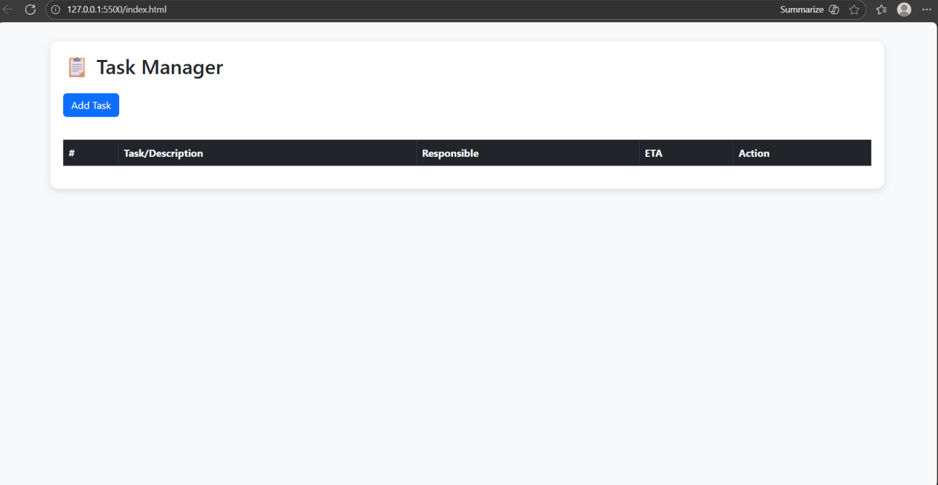

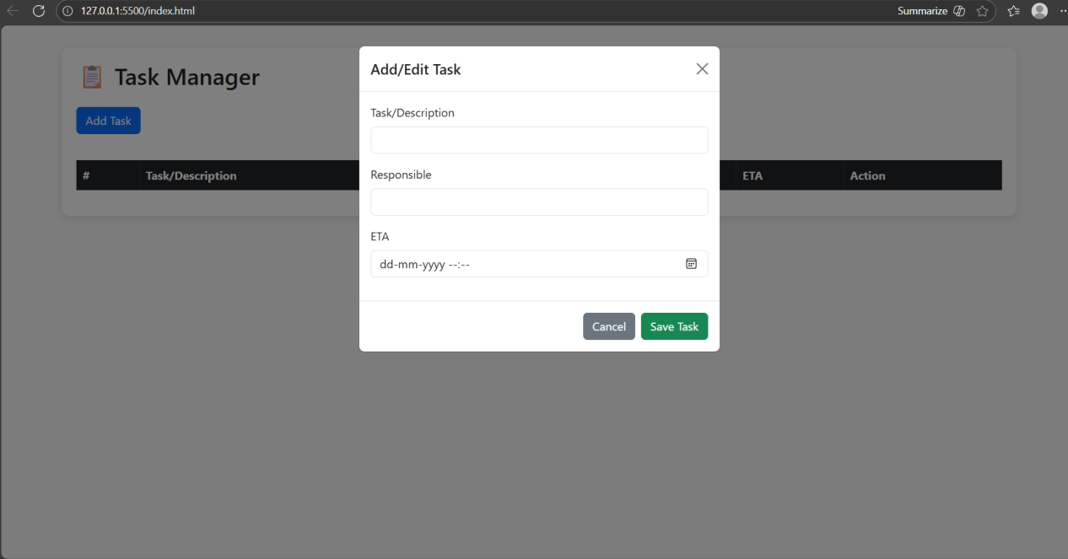

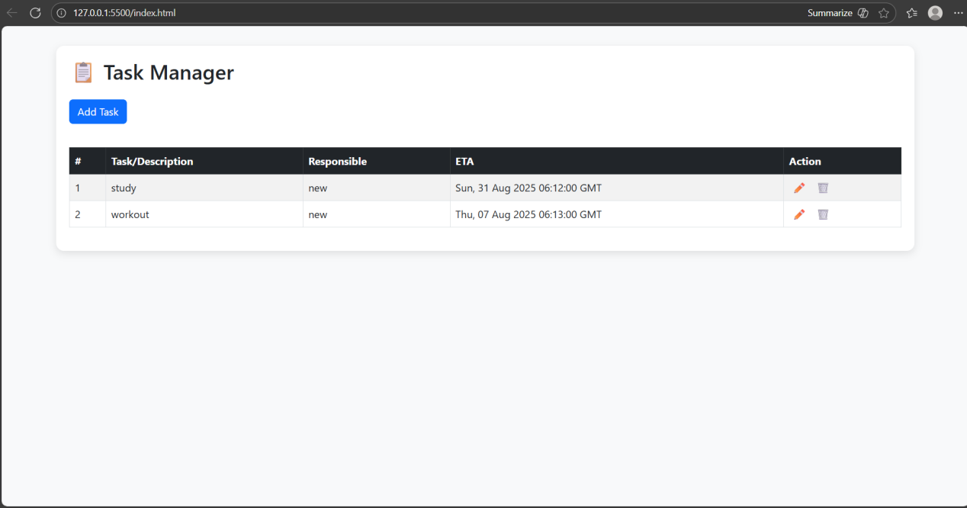

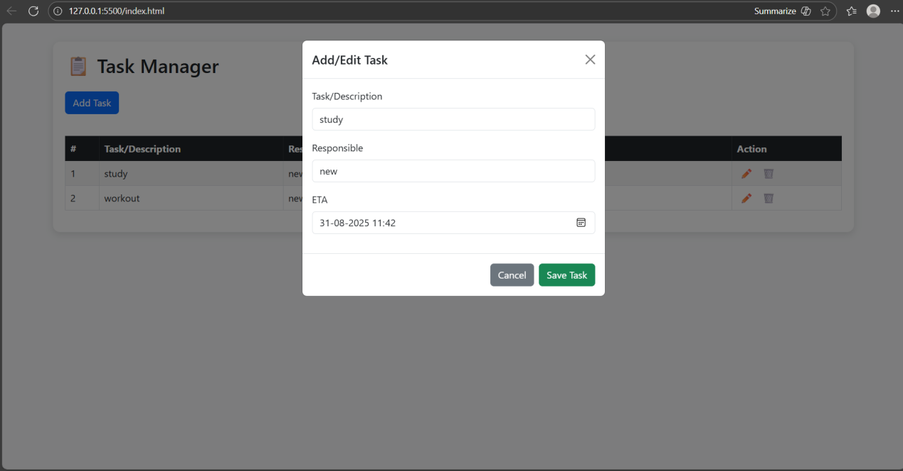

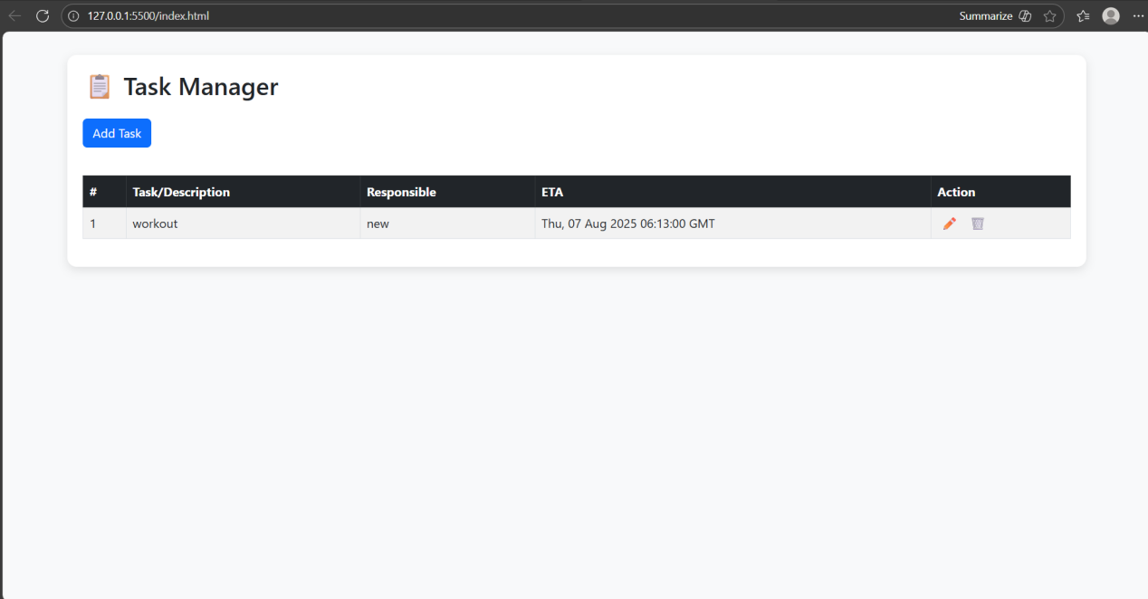

CONCLUSION
The HTML To-Do List project represents a fundamental yet highly effective exercise in front-end web development. This project successfully demonstrates how basic web technologies such as HTML, CSS, and JavaScript can be integrated to create a practical and interactive application that addresses a common real-world need—managing daily tasks efficiently.
Key Outcomes of the Project
Functionality Achievement:
- The project meets all primary objectives by providing users with the ability to add, view, mark complete, and delete tasks.
- The single-page design ensures smooth user interaction, as all operations are performed dynamically without page reloads.
- The optional integration of localStorage enhances usability, allowing tasks to persist even after the page is refreshed.

User Experience and Interface Design:
- A clean, responsive, and visually appealing interface was implemented using CSS and design best practices.
- Completed tasks are clearly distinguished using a strikethrough effect, while hover effects and buttons provide visual cues for interaction.
- The design adapts seamlessly across desktop, tablet, and mobile devices, ensuring accessibility and convenience for all users.
Educational and Practical Value:
- Interns gain hands-on experience in DOM manipulation, event handling, and dynamic content updates, which are crucial skills in modern web development.
- The project emphasizes the importance of planning, coding standards, and debugging practices, providing a solid foundation for future web projects.
- It demonstrates how simple web applications can solve everyday problems efficiently and intuitively.
Scalability and Future Enhancements:
- The modular and structured design allows for easy scalability.
- Future improvements could include features such as task categorization, deadline management, reminders, cloud synchronization, and collaborative task lists.
- Adding these advanced functionalities can transform the project into a comprehensive productivity tool suitable for professional or educational use.
Learning Outcomes
Front-End Development Skills:
- Gained proficiency in HTML5 for content structure, CSS3 for styling, and JavaScript for dynamic behavior.
- Learned to handle events, manipulate the DOM, and validate user inputs effectively.

Responsive Design Principles:
- Developed the ability to create layouts that adapt to multiple screen sizes.
- Applied visual feedback techniques such as hover effects, strikethroughs, and button styling to enhance user interaction.
Problem-Solving and Logical Thinking:
- Tackled challenges related to task management, event handling, and dynamic updates.
- Learned to debug JavaScript errors, optimize code performance, and ensure browser compatibility.
Project Planning and Documentation:
- Gained experience in methodical project development, from requirement analysis to testing and deployment.
- Developed skills in documenting workflows, writing reports, and presenting project outcomes professionally.
Practical Implications
The HTML To-Do List is more than a learning exercise; it is a real-world tool that enhances productivity:
- Users can organize their daily schedules, track task completion, and remove unnecessary tasks.
- It demonstrates that even basic web technologies can be leveraged to create practical, usable applications.
- The project bridges the gap between academic exercises and real-life applications, providing a sense of accomplishment and tangible utility.

